September 4, 2020

Use of Bioelectrical Stimulation and Biologics for the Treatment of Stress Urinary Incontinence:
A Pilot Safety and Feasibility Trial
Cristiane Carboni, MSC, PhD, Alexis Foniari, MD
Porto Alegre, Brazil

Introduction:
Dysfunction of the lower urinary tract, including incontinence is a very common clinical problem effecting millions of men and women of all ages. Regenerative medicine has a potential to provide a hope for the recovery of lost bladder and sphincter control. (1) Incontinence can be caused by several diseases or anatomical alterations the effect the normal cellular and extracellular matrix (ECM) compartments which accomplish the role of storage and control of voiding. The inner lining of the bladder which is called the urothelium, is necessary to prevent the passage of hypertonic urine to the blood and the exchange of toxic metabolites. In a state of homeostasis, adult urothelial cells are quiescent, however, if the urothelium is damaged by an acute lesion or a exposure to toxins, a rapid process of exfoliation and regeneration is induced (2).
The normal functioning urinary bladder is composed of two main parts: a compliant muscular wall and a highly specialized urothelium. It is well know that the pelvic floor muscles (PFM) play an important roll in the management of lower urinary tract symptoms as well (LUTS), including incontinence (3). When the bladder is damaged, all these properties must be taken into account for a global functional recovery (4).
The potential use of bioelectrical stimulation (BES) for lower urinary tract dysfunction was initially investigated in animal models, where it caused bladder relaxation by inhibiting the parasympathetic motor neurons. Exploration at the molecular level in an animal model revealed that stress urinary incontinence (SUI) mice exhibit disordered collagen metabolism and corresponding changes in the TGF-β1-Smad2/3 pathway. After BES therapy, the collagen levels increased and the TGF-β1-Smad2/3 pathway was activated in response to mechanical strain. These results indicate that collagen metabolism and the TGF-β1-Smad2/3 pathway are potentially involved in the pathogenesis of SUI as well as in the response to BES therapy (5).
Other studies showed that BES causes contractions of the pelvic floor, increasing the number of muscle fibers with rapid contraction (6). The BES also increases the blood flow to the urethra and PFM, improving the neuromuscular connections, muscular fiber function, genital atrophy improving the mechanism of urethral closure (7),(8) and also induces epithelial cell migration, macrophages, mast inhibition, fibroblasts proliferation and motor axonal regeneration (9).
BES is widely used for overactive bladder syndrome (OAB). The effect of BES in afferent pathways provides a preganglionic central inhibition of bladder’s motor neuron influencing the detrusor activity, but the effects of this therapy in the sacral region are better known. In animal models have demonstrated that bladder relaxation can also be induced by the inhibition of parasympathetic motor neurons (10). Other factors involved in OAB usually includes weakness of the pelvic floor muscles as well(11).
Previous work by this investigator using BES for bladder incontinence in a randomized prospective controlled study of stimulation of the sacral or tibial nerves via acupuncture needles demonstrated that sacral nerve stimulation was superior to tibial nerve and that both were significantly superior to the patient’s prs-study assessment of the frequency of incontinence.
There have been advances in the understanding of mechanisms of several biologics including stem cells, exosomes, amniotic fluid, Platelet Rich Plasma, and organ-specific matrix, as well as many additional factors such as nutrient hydrogel. Individually, each of these agents have been proved to induce organ and/or tissue repair and regeneration. They have largely been delivered by direct tissue injection in most indications due to the near total filtration by the lungs, spleen and liver if infused intravenously. The bladder is easily accessible by direct cystoscopy, and delivery of agents from stem cells to Botox have been shown to be both safe and effective as demonstrated in the video listed below. Delivery of these agents is easily performed using catheters with a small size needle on the tip, which is able to lift the urothelium of the bladder and deliver these agents into the muscle layer of the bladder in multiple sites including the trigone at the base of the bladder and urethral sphincter, without perforation of the bladder wall as demonstrated by the Co-PI of this study.
(VTS_01_1jamie.MP4)
The hypothesis of this study is that BES of pelvic floor and two of the primary nerves innervating bladder, to upregulate the expression of pro-regenerative proteins, plus delivery of multiple biologics directly into the bladder to further enhance bladder regeneration and tone will be a ground breaking new, and relatively non-invasive approach to bladder dysfunction and incontinence.

Study Name: Bioelectric Stimulation and Direct Injection of Biologics for Treatment of Bladder Incontinence
Study Sponsor: BladderCell, a subsidiary of Leonhardt Ventures, LLC
Principle Investigators: Cristiane Carboni, MSC, PhD, Director Pelvic Floor World Clinic
Alexis Foniari, MD, Urology Clinic
Number of Study Sites: 1
Study Location: Pelvic Floor Dysfunction Clinic, Porte Allegre, Brazil and
Santa Casa de Porte Alegre Hospital
Study Design: Prospective, Single Arm, Open Label, Combination Therapy, Pilot Trial
Number of Subjects: 10-20 with rolling enrollment
Number of Treatment Arms: 1 with two components
Duration of Each Treatment: 30 minutes for each BES treatment and
30-45 minutes for each cystoscopy and delivery of Biologics
Frequency of Treatments: 2 x’s/week for two months for BES
Baseline, months 1 & 2 of study for Biologic Delivery
Number of Treatments: 16 for BES, 3 for Biologic delivery
Stimulator to be Used: CE Mark and FDA 510K approved Mettler model 740 Stimulator
Bioelectric Stimulation Signals: SDF-1; VEGF; PDGF; IGF; Klotho; Collagen17A
Injected Regenerative Products: Tropoelastin, Exosomes, Tropoelastin, Klotho
Primary End Point: Change in questionaires and self-assessment of severity and frequency of urinary incontinence including number of urinations/day and number of pads used/day.
Secondary End Point: Safety of direct injection of multiple biologics combined with multiple sites of BES, as well as painful urination, hematuria lasting more than 3 days, urgency, or local irritation as sites of BES
General objective:
The present study aims to evaluate the feasibility and efficacy of combining BES at three different sites of nerve stimulation, plus direct injection of multiple biologics into the bladder wall, on the improving bladder function and LTUS and frequency of incontinence using questionaires, clinical patient assessment as study end points, and objective quantitation to assess the reduction in severity of stress incontinence.
Inclusion Criteria:
- Women age 30-70 years of age
- History of stress induced or related bladder incontinence of more than 15 urinations/day for over 3 months
- No history of previous bladder surgery or use of devices to improve bladder suspension
- No history of bladder cancer
- No documented or frequent urinary track infection
- Able to attend all clinic visits and undergo the 3 cystoscopy and bladder injection procedures
- Adequate cognitive function to read and understand the study and Consent Form
Exclusion Criteria:
- History of recurrent urinary tract infection (> 3 within the previous year)
- Bladder pathology or dysfunction because of fistula, tumor, pelvic irradiation, neurological or other
- Any previous surgical or device treatment of incontinence during the previous 12 months
- Bleeding disorder on currently taking anti-coagulant or anti-platelet medications
- Genital prolapse to, or beyond, the introitus,
- Cardiac pacemaker or internal defibrillator

Protocol:
This will be a prospective, single arm, multiple component, open label, clinical trial that will enroll 10 patients seeking treatment for bladder incontinence from a clinic focused on pelvic floor disorders including urinary incontinence, with chronic complaints of urinary incontinence or more than 3 months duration requiring use of absorbent pads. The intervention period will last 12 weeks with two months follow up after the end of treatment to evaluate the durability of benefit without ongoing treatment.

End Point Questionaires: All subjects will complete self-assessment of the severity of their symptoms, both pre and post treatment using validated questionaires for severity of incontinence including: PRAFAB-score, OAB-V8, PGI-I, Pelvic Floor Impact Questionnaire-short form 7 and King’s Health Questionnaire.
Pre-Treatment Screening:
All enrolled subjects will have an evaluation of pain sensitivity to select the current that is comfortable to them that is at, or above, the minimal level for the study. The current will be increased to a comfort predetermined by the patient and below the motor threshold that does not cause muscle contraction and is at or above the minimum current to be used for the study.
BES Treatment:
Each treatment for all subjects will be for 30 minutes twice a week for 12 weeks and take place only in the clinic of an approved Site Principal Investigator. The BES treatments will be done on a different day than the delivery of biologics.
The location of the patch gel electrodes will be on the Pelvic Floor opposite the anus, and over both Sacral and Tibial Nerves as shown in the images in the Appendix, using two sets of electrodes first for the Pelvic Floor location, then followed by simultaneous stimulation of the Sacral and Tibial nerves, followed by a similar period for the Pelvic Floor. The electrodes will be connected to the Mettler stimulator and turned on for the 30 minute periods of BES first for the Pelvic Floor, followed by the Sacral and Tibial nerves. (See Images of location of electrodes at end of Atttachments). The current will then be turned on and increased to the level pre-selected by each patient and will be the current used for the duration of each treatment per protocol.
Catheter Delivery of Biologics:
All patients will be kept NPO for a minimum of 6 hours, and void 15 minutes prior to being brought to the procedure room for the elective cystoscopy. Patients will be given light conscious sedation if desired.
A standard cystoscope will be advanced into the bladder to visualize the entire bladder wall to identify any unsuspected findings that might preclude conduct of the study. This catheter will be removed and a delivery catheter inserted which contains and extrudable small gauge beveled needle at the tip. The catheter will be advanced to the trigone and area of the urethral sphincter, and the needle extruded in a plane parallel with the bladder wall, and under direct visualization used to lift the urothelium to allow sequential injection of the four biologic agents, (tropoelastin, exosomes, bladder matrix, and Klotho), into the bladder wall in approximately 10 sites by individual syringe injection . At the completion of the injections the bladder will be inspected for abnormal bleeding, and if no significant bleeding noted, the needle will be retracted and the catheter removed from the patient. The subject will be recovered in the area typically used post Urology procedures, and will remain until they are able to void without difficulty and stand without problem, and then be discharged to home. Each subject will have a repeat of this procedure at one and two months from the initial procedure.
Stopping Rules:
The study of an individual subject will be paused for any subject that develops symptoms or adverse events that in the opinion of the PI are directly related to the BES treatment.
The entire study will be paused if 3 subjects develop adverse events of moderate severity
Until an action plan is put in place as a mediation of the adverse events reported.
FollowUp:
All patients will have one follow up clinic visit at two months after the end of treatment and a final set of questionaires and other end points will be completed to assess the durability of the therapy.
Statistical Analysis: All deidentified patient data will be collated and analyzed by a statistician not involved in the study. Changes in questionnaire scores from baseline to end of treatment, and other end points such as number of absorbent pads used daily, will be reported as the mean +/- standard deviation as well as median and range. Final analysis will be given to the Principal Investigator and study sponsor.
The protocol may be amended before other potential subjects are enrolled to include the addition of other potential BES signals or injected agents. Enrollment will then be resumed and further extension in enrollment will be allowed if the sponsor and Principal Investigators agree.

References
1. Imamura T, Ishizuka O, Yamamoto T, Gotoh M, Nishizawa O. Bone marrow-derived cells implanted into freeze-injured urinary bladders reconstruct functional smooth muscle layers. LUTS Low Urin Tract Symptoms. 2010;2(1):1–10.
2. McCloskey KD. Bladder interstitial cells: An updated review of current knowledge. Acta Physiol. 2013;207(1):7–15.
3. Yani MS, Wondolowski JH, Eckel SP, Kulig K, Fisher BE, Gordon JE, et al. Distributed representation of pelvic floor muscles in human motor cortex. Sci Rep. 2018;8(1):1–16.
4. Serrano-Aroca Á, Vera-Donoso CD, Moreno-Manzano V. Bioengineering approaches for bladder regeneration. Int J Mol Sci. 2018;19(6):1–26.
5. Vallinga MS, Spoelstra SK, Hemel ILM, van de Wiel HBM, Weijmar Schultz WCM. Transcutaneous Electrical Nerve Stimulation as an Additional Treatment for Women Suffering from Therapy‐Resistant Provoked Vestibulodynia: A Feasibility Study. J Sex Med [Internet]. 2015 Jan;12(1):228–37. Available from: https://linkinghub.elsevier.com/retrieve/pii/S1743609515308985
6. Fall M, Lindström S. Electrical stimulation. A physiologic approach to the treatment of urinary incontinence. Urol Clin North Am [Internet]. 1991 May;18(2):393–407. Available from: http://www.ncbi.nlm.nih.gov/pubmed/2017820
7. Correia GN, Pereira VS, Hirakawa HS, Driusso P. Effects of surface and intravaginal electrical stimulation in the treatment of women with stress urinary incontinence: Randomized controlled trial. Eur J Obstet Gynecol Reprod Biol. 2014;173(1):113–8.
8. Spruijt J, Vierhout M, Verstraeten R, Janssens J, Burger C. Vaginal electrical stimulation of the pelvic floor: A randomized feasibility study in urinary incontinent elderly women. Acta Obstet Gynecol Scand. 2003;82(11):1043–8.
9. Martínez EP, Jiménez RV, Rivera AR, Niño-de-Rivera L. Electrical stimulation to vagina muscle cells and rabbit bladder muscle and epithelial cells in-vitro to change growth factor. 2009 6th Int Conf Electr Eng Comput Sci Autom Control CCE 2009. 2009;1–6.
10. Rodrigues RF, Silva EB da, Rodrigues RF, Silva EB da. Intracavitary electrical stimulation as treatment for overactive bladder: systematic review. Fisioter em Mov [Internet]. 2016;29(4):813–20. Available from: http://www.scielo.br/scielo.php?script=sci_arttext&pid=S0103-51502016000400813&lng=en&tlng=en
11. Greer JA, Smith AL, Arya LA. Pelvic floor muscle training for urgency urinary incontinence in women: A systematic review. Int Urogynecol J. 2012;23(6):687–97.

Annexes:

Annexes 1 - PRAFAB score

PRAFAB score: The patient was asked to give the most appropriate answer;
only one answer per section was possible
Protection
1 I never use pads for urinary incontinence
2 I occasionally use pads or have to change underwear
3 As a rule I use pads or have to change underwear more than once a day
4 I always use pads for urinary incontinence
Amount
1 My loss of urine is limited to an occasional drop
2 My loss of urine can sometimes be as much as a teaspoon
3 My loss of urine is enough to really wet my pads and/or clothing
4 My loss of urine usually completely soaks my pads and/or clothing
Frequency: Involuntary loss of urine occurs
1 Once a week or less
2 More than once but less than three times a week
3 More than three times a week but not every day
4 Every day
Adjustment: My urinary incontinence
1 Does not inhibit me in my daily activities
2 Made me quit some activities like sports or other strenuous exertion
3 Made me quit most activities that provoke my urinary incontinence
4 Prevents me from leaving the house altogether
Body image
1 I am not really bothered by my urinary incontinence
2 My urinary incontinence is an inconvenience but not a real problem
3 My urinary incontinence makes me feel unclean
4 I am disgusted with myself because of my urinary incontinence

Annexes 2 - OAB-V8

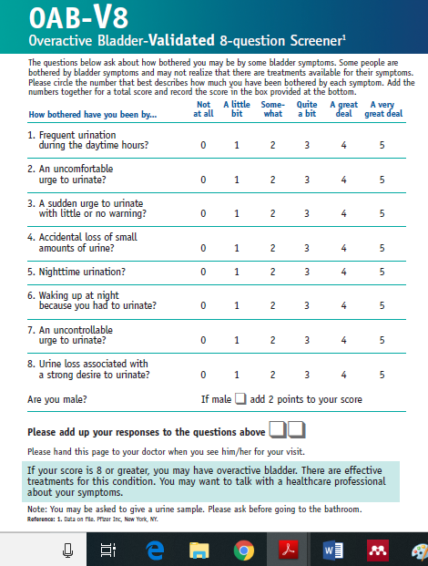

Annexes 3 – Patient Global Impression of Improvement

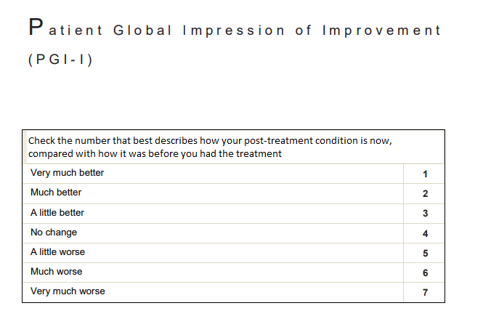

Annexes 4 - Pelvic Floor Impact Questionnaire—short form 7 (PFIQ-7)

Pelvic Floor Impact Questionnaire—short form 7 (PFIQ-7)

Name DATE
DOB

Instructions: Some women find that bladder, bowel, or vaginal symptoms affect their activities, relationships, and feelings. For each question, check the response that best describes how much your activities, relationships, or feelings have been affected by your bladder, bowel, or vaginal symptoms or conditions over the last 3 months. Please make sure you mark an answer in all 3 columns for each question.

How do symptoms or conditions in the following
usually affect your
- Ability to do household chores (cooking, laundry
housecleaning)?

Bladder or urine

□Not at all
□Somewhat
□Moderately
□Quite a bit

Bowel or rectum

□Not at all
□Somewhat
□Moderately
□Quite a bit

Vagina or pelvis

□Not at all
□Somewhat
□Moderately
□Quite a bit

- Ability to do physical activities such as walking,
swimming, or other exercise?
□Not at all
□Somewhat
□Moderately
□Quite a bit
□Not at all
□Somewhat
□Moderately
□Quite a bit
□Not at all
□Somewhat
□Moderately
□Quite a bit

- Entertainment activities such as going to a
movie or concert?
□Not at all
□Somewhat
□Moderately
□Quite a bit
□Not at all
□Somewhat
□Moderately
□Quite a bit
□Not at all
□Somewhat
□Moderately
□Quite a bit

- Ability to travel by car or bus for a distance
greater than 30 minutes away from home?
□Not at all
□Somewhat
□Moderately
□Quite a bit
□Not at all
□Somewhat
□Moderately
□Quite a bit
□Not at all
□Somewhat
□Moderately
□Quite a bit

- Participating in social activities outside your
home?
□Not at all
□Somewhat
□Moderately
□Quite a bit
□Not at all
□Somewhat
□Moderately
□Quite a bit
□Not at all
□Somewhat
□Moderately
□Quite a bit

- Emotional health (nervousness, depression,
etc)?
□Not at all
□Somewhat
□Moderately
□Quite a bit
□Not at all
□Somewhat
□Moderately
□Quite a bit
□Not at all
□Somewhat
□Moderately
□Quite a bit

- Feeling frustrated? □Not at all
□Somewhat
□Moderately
□Quite a bit
□Not at all
□Somewhat
□Moderately
□Quite a bit
□Not at all
□Somewhat
□Moderately
□Quite a bit

Total x 100 x 100 x 100 Scoring the PFIQ-7: =

All of the items use the following response scale:
0, Not at all; 1, somewhat; 2, moderately; 3, quite a bit PFIQ-7 Score Scales:

Urinary Impact Questionnaire (UIQ-7): 7 items under column heading “Bladder or urine”
Colorectal-Anal Impact questionnaire (CRAIQ-7): 7 items under column heading “Bowel / rectum”
Pelvic Organ Prolapse Impact Questionnaire (POPIQ-7): Items under column “Pelvis / Vagina”
Scale Scores: Obtain the mean value for all of the answered items within the corresponding scale (possible value 0 – 3) and then multiply by (100/3) to obtain the scale score (range 0-100).
Missing items are dealt with by using the mean from answered items only. PFIQ-7 Summary Score: Add the scores from the 3 scales together to obtain the summary score (range 0-300).

Annexes 5 – The King’s Health Questionnaire
THE KING’S HEALTH QUESTIONNAIRE

How would you describe your health at the present?
Please tick one answer

Very good Good Fair
Poor Very poor

- How much do you think your bladder problem affects your life?

Please tick one answer

Not at all A little
Moderately A lot

Please turn the page

Below are some daily activities that can be affected by bladder problems. How much does your bladder problem affect you?

We would like you to answer every question. Simply tick the box that applies to you

 | 1 | 2 | 3 | 4
3. ROLE LIMITATIONS | Not at all | Slightly | Moderately | A lot
A. Does your bladder problem affect your
household tasks? (cleaning, shopping etc)

B. Does your bladder problem affect your job, or your normal daily activities outside the home?

1 2 3 4
4. PHYSICAL/SOCIAL LIMITATION Not at all Slightly Moderately A lot

A Does your bladder problem affect your physical activities (e.g. going for a walk, running, sport, gym etc)?
- Does your bladder problem affect your ability to travel?

- Does your bladder problem limit your social life?

- Does your bladder problem limit your ability to see and visit friends?
5. PERSONAL RELATIONSHIPS
0
Not Applicable
1
Not at all
2
3
Slightly Moderately
4
A lot
- Does your bladder problem affect your relationship with your partner?

- Does your bladder problem affect your sex life?

- Does your bladder problem affect your family life?

 | 1 | 2 | 3 | 4
- EMOTIONS  - Does your bladder problem make | Not at all | Slightly | Moderately | Very much
you feel depressed?

  - Does your bladder problem make you feel anxious or nervous?

  - Does your bladder problem make you feel bad about yourself?

 | 1 | 2 | 3 | 4
7.SLEEP/ENERGY | Never | Sometimes | Often | All the time
A. Does your bladder problem
affect your sleep?
B. Does your bladder problem make
you feel worn out and tired ?
8.Do you do any of the following? |  | If so how much?
 | 1 | 2 3 |  | 4
 | Never | Sometimes Often |  | All the time
A. Wear pads to keep dry?
B. Be careful how much
fluid you drink ?

- Change your underclothes because they get wet?

- Worry in case you smell?

We would like to know what your bladder problems are and how much they affect you ? From the list below choose only those problems that you have at present. Leave out those that don’t apply to you.

How much do they affect you? FREQUENCY: going to the toilet very often

A little 2.Moderately 3. A lot

NOCTURIA: getting up at night to pass urine

1. A little 2.Moderately 3. A lot

URGENCY: a strong and difficult to control desire to pass urine

1. A little 2.Moderately 3. A lot

URGE INCONTINENCE: urinary leakage associated with a strong desire to pass urine

1. A little 2.Moderately 3. A lot

STRESS INCONTINENCE: urinary leakage with physical activity eg. coughing, running

1. A little 2.Moderately 3. A lot

NOCTURNAL ENURESIS: wetting the bed at night

1. A little 2.Moderately 3. A lot

INTERCOURSE INCONTINENCE: urinary leakage with sexual intercourse

1. A little 2.Moderately 3. A lot

WATERWORKS INFECTIONS
1. A little 2.Moderately 3. A lot

BLADDER PAIN
- A little 2.Moderately 3. A lot

Thank You For Your Time

To Calculate Scores

PART 1

  - General Health Perceptions
Very good 1
Good 2
Fair 3
Poor 4
Very poor 5
Score = ((Score to Q1 – 1)/4) x 100
  - Incontinence Impact
Not at all 1
A little 2
Moderately 3
A lot 4
Score =((Score to Q2 – 1)/3) x 100

PART 2
Individual scores as recorded at the top of each column of possible responses
  - Role limitations
Score =(((Scores to Q 3A + 3B) – 2)/6) x 100
  - Physical limitations
Score =(((Scores to Q 4A + 4B) – 2)/6) x 100
  - Social limitations
[If 5C >/= 1] Score =(((Score to Q 4C + 4D + 5C) – 3)/9) X 100
[If 5C = 0] Score =(((Score to Q 4C + 4D) – 2)/6) x 100

  - Personal relationships
[If 5A+5B >=2]Score =(((Scores to Q 5A + 5B) – 2)/6) x 100 [If 5A+5B =1] Score =(((Scores to Q 5A + 5B) – 1)/3) x 100 [If 5A+5B =0] Treat as missing value
  - Emotions
Score =(((Score to Q 6A + 6B + 6C) – 3)/9) X 100

  - Sleep / energy
Score =(((Scores to Q 7A + 7B) – 2)/6) x 100
  - Severity measures
Score =(((Scores to Q 8A + 8B + 8C + 8D) – 4)/12) x 100

PART 3

Scale | score
Omitted | 0
A little | 1
Moderately | 2
A lot | 3

LOCATION OF SURFACE ELECTRODES FOR BES:
Pelvic Floor:
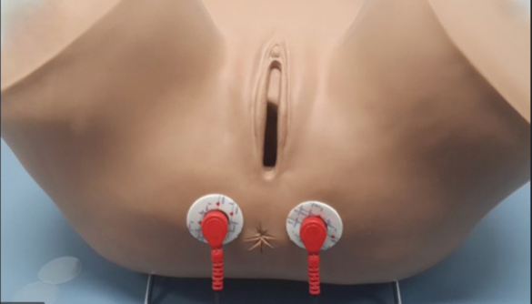

Sacral Nerve:
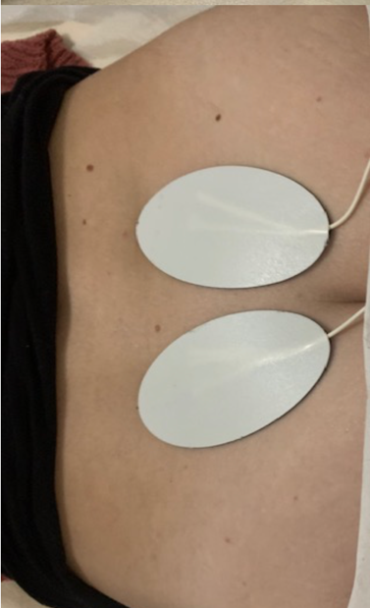

Tibial Nerve:
