March, 2022

ORTHOPEDICELL CLINICAL PROTOCOL
KNEE OSTEOARTHRITIS USING BIOLECTRIC STIMULATION

Background:

Osteoarthritis, especially of the knees and elbows, effects tens of thousands of people in the US. This condition has many causes, including routine osteoarthritis associated with advancing age, as well as previous injury, obesity, and other factors, which result in loss of articular cartilage leading to the significant pain due to “bone-on-bone” finding on imaging. There are many treatments on the market, ranging from the most aggressive being total knee replacement with a prosthetic joint, to non-invasive treatments, most of which are based on very little if any science, and offer variable benefit in most patients.

The body has a number of electrical fields as evidenced by the EKG. EEG, and the EMG. Bioelectric stimulation is a growing field that takes advantage of manipulating electrical fields using non-invasive micro-current stimulation of the target tissue at very precise frequencies. Decades of research have led to identification of the precise frequency that is the signature of up to 13 pro-regenerative proteins in the body. Stimulation of that precise signal can induce the controlled expression and upregulation of the protein, each of which has been shown to be beneficial in organ regeneration. This includes multiple growth factors such as IGF, HGF, PDGF, EGF, HGF, and VEGF, and a protein that is reduced with age called Klotho. The stimulator used is a 510K approved programmable device that delivers each of the signals at specific duration and strength for that protein, and in any sequence selected. This strategy much more closely mimics the multiple proteins involved in native tissue and organ repair.

OrthoStim is an approach to the treatment of orthopedic problems including osteoarthritis, that is based primarily on use of bioelectric stimulation to deliver a combination of precise non-invasive microcurrent signals to the knee joint to upregulate the local tissue expression of six pro-regenerative target proteins that drive native stem cell recruitment, proliferation, and differentiation, to achieve significant pain relief and regeneration of cartilage¹⁻⁹. It has been used in many patients for a variety of clinical conditions and proven safe, including now being evaluated as an anti-cancer therapy. All subjects in this study will receive bioelectric stimulation (BES) delivered by a Mettler stimulator which has FDA 510K approval for the indications of pain relief, improved blood supply, improved muscle function, and improved wound healing. The stimulator is connected to patch electrodes on the sides of the knee. Each patient will receive bioelectric stimulation treatments twice/week for 30 minutes for 8 weeks.

In addition, patients will receive a Prizm knee wrap that provides additional microcurrent bioelectric stimulation. Prizm Medical, Inc. develops and manufactures electrotherapy devices for therapeutic pain management, increased blood circulation, improve range of motion, and retardation of disuse atrophy (muscle wasting). Their products include mesh wraps that contain microelectrodes and are connected to a small light weight stimulator worn on the ankle at home for 30 minutes daily to provide additional bioelectric stimulation to enhance clinical benefit. The stimulators are pulsed direct current neuromuscular and TENS pain relief stimulators. It also has 510K approval to treat acute and chronic injuries, sources of pain, increase circulation while improving range of motion, and to minimize soft tissue atrophy and injury and has been used in over 250,000 patients with documented benefit. The wrap is to be worn for 30 minutes daily to deliver more bioelectric stimulation and benefit.

Study Description:
This is a prospective, non-randomized, open label, consecutive series pilot study to evaluate the safety and feasibility of OrthoStim treatment regimen to relieve the pain and disability of significant osteoarthritis of the knee. The treatment regimen is detailed below.

The study, including protocol and consent form, will have been approved without stipulations by the Institutional Review Board at Hoag Hospital as meeting safe and good clinical practice before any subject will be enrolled.

Target Number Enrolled: 20
Number of Enrolling Sites: 2

PROTOCOL:

Inclusion Criteria:

- Age 40-80 yrs of age
- Subjects must be in good health with a BMI < 35.
- Significant knee osteoarthritis by imaging within 3 months of treatment
- Willing to be present for the required treatment/study visits.
- Willing to complete the required questionaire of the level of pain and limitation of mobility at the specified intervals before and at the end of treatment
- Willing and able to give informed consent and follow study instructions and requirements.

Exclusion Criteria:

- Patients who have a planned arthroscopic procedure on the knee intended for treatment of osteoarthritis in the next 3 months.
- History of bleeding disorder
- Individuals with diminished decision-making capacity
- Current Smoking or use of other tobacco products.
- Pregnancy or current breast feeding for females

Screening/Study Enrollment:
Any subject with qualifying osteoarthritis pain and reduced mobility who meet all the Inclusion and none of the Exclusion criteria, will be eligible for participation. Each potential subject will have a brief history and examination performed by the Investigator or designee, and if acceptable, will be provided with an overview of the study and offered an opportunity to review the Consent Form.
If they choose to participate, and sign the Consent form, they will be enrolled in the study.

Treatment Schedule:

Bioelectric Stimulator: Mettler 240 stimulator
Duration of Each Treatment: 30 minutes
Frequency of Treatments: twice/week for four weeks, then once/week for 8 weeks
Total Treatment Period: 12 weeks, 16 total treatments

Treatment Components:
Knee Brace BES Delivery System:

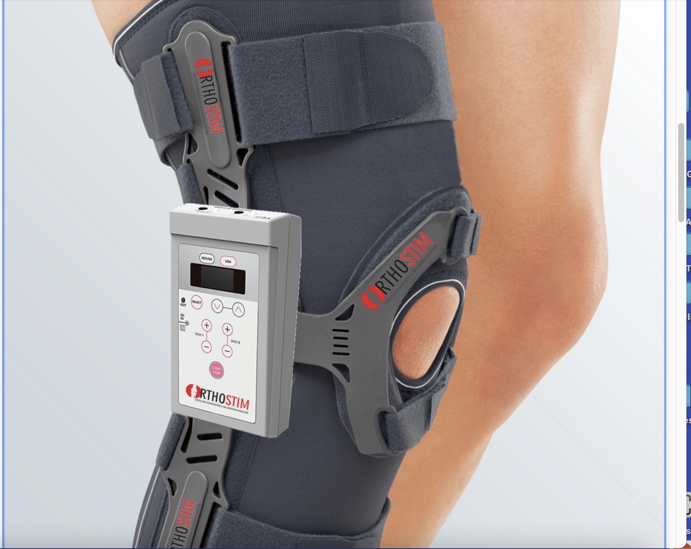

Bioelectric Stimulation:
Mettler
All patients will receive a series of bioelectric stimulation treatments as detailed above to the treated knee via a set of surface electrodes placed on the both sides of the knee, and connected to a Mettler 510 K approved desk top stimulator with all treatments delivered in the outpatient clinic.
Prizm
In addition, patients will be given a knee wrap to use a minimum of 30 minutes/day, which includes embedded electrodes that will be connected to a small wearable stimulator to provide additional bioelectric stimulation at home.
Specific proteins to be stimulated:
VEGF, PDGF, IGF, HGF, and KLOTHO

Screening Test of Bioelectric Stimulation:
All patients enrolled in the study will have a screening test to assure the safety and tolerability of the BES treatment regimen on the opposite knee before use in the study. This will be done by placement of patch electrodes on both sides of the non-involved knee and connected to a Mettler bioelectric stimulation signal generator that has been previously tested and proven to be capable of delivering the required current. The stimulator will be turned on and run for up to a 20 minute period of escalating currents to a minimum of 1mAmp and peak of 4 mAmps to test tolerability of the stimulation in each patient. If there is no significant skin irritation or pain or adverse effect at the end of the test period of bioelectric stimulation, the patient will be eligible for participation in the study.

Protocol:
Each enrolled patient will have BES stimulation applied to the effected knee for 30 minutes at each protocol treatment session using patch electrodes placed on the medial and lateral sides of the knee, The electrodes will be connected to the Mettler stimulator and the current initiated and increased to the minimum of 2 mAmps for a period of 30 minutes.
Each subject will also receive a Prizm portable stimulator for home use which includes a small stimulator that is worn at the ankle and held in place by Velcro strap, and connected to electrodes placed on the sides of treated knee. It is to be worn during sleep only and removed each morning.

Study End Points:
Pain Assessment:
All eligible subjects will complete a baseline questionaire to evaluate the amount of pain and disability before starting treatment. This survey will be repeated at the end of the 12 week treatment period, and then at 1 and 3 months of follow up post treatment.
Range of Motion Assessment:
In addition to the questionaire, the change in range of motion of the effected knee will be measured by a technician trained in this assessment tool before and at the end of the 12 week treatment.

Sponsor Provided Equipment
All treatment-related components will be provided to the clinic by the Sponsor including:
- Mettler 740 bioelectric stimulator
- A supply of Patch electrodes
- Prizm knee wrap with embedded electrodes and wearable stimulator

Pause/Stopping Rules:
Treatment will be paused for any complaint by the patient of significant or intolerable pain or discomfort, or local adverse effect. The patient will be allowed to resume treatment after a minimum of seven days at the investigator discretion.

Follow Up Evaluations:
Each patient will have a follow up visit at month 1, 2, and 3 post study initiation at the clinic to complete the self-assessment survey and have range of motion and pain assessed a designated individual trained in this survey.
Each subject will also have a brief interview inquiring about any adverse effects noted by the subject since enrolling in the study.
Grading Survey and Range of Motion:
Both the subject and the investigator will independently grade the level of pain and limitation of motion in response to treatment as Mild, Good, or Very Good. The results of all 20 enrolled subjects will be collated by the clinic and submitted to the sponsor within two weeks of study completion.

Additional Subjects: Additional subjects may be enrolled into the study if approved by the local IRB Committee, the Principal Investigator, and the Sponsor.

References:

Bioelectric Stimulation

- Hunckler J, de Mel A. Hunckler J¹, de Mel A¹. A current affair: electrotherapy in wound healing. J Multidiscip Healthc. 2017 Apr 20;10:179-194.
- Birmingham k, Gradinaru V, Ludwig K, Famm K. Bioelectronic medicines: A research roadmap. Nat Rev Drug Discovery. 2014;13(6):399-407
- McLaughlin KA, Levin M. Bioelectric signaling in regeneration: Mechanisms of ionic controls of growth and form. Dev Biol. 2018 Jan 15;433(2):177-189
- Jacob J¹, More N¹, Kalia K¹, Kapusetti G¹. Piezoelectric smart biomaterials for bone and cartilage tissue engineering. Inflamm Regen. 2018 Feb 27;38:2. doi: 10.1186/s41232-018-0059-8. eCollection 2018.
- Reddi AH. Morphogenesis and tissue engineering of bone and cartilage: inductive signals, stem cells, and biomimetic biomaterials. Tissue Eng. 2000; 6(4):351–9.

Hoare JI, Rajnicek AM, McCaig CD, Barker RN, Wilson HM. Electric fields are novel determinants of human macrophage functions. J Leukoc Biol. 2016;99(6):1141–1151.
- Rouabhia M, Park H, Meng S, Derbali H, Zhang Z. Electrical stimulation promotes wound healing by enhancing dermal fibroblast activity and promoting myofibroblast transdifferentiation. PLoS One. 2013; 8(8):e71660.
- Gurgen SG, Sayin O, Cetin F, Tuc Yucel A. Transcutaneous electrical nerve stimulation (TENS) accelerates cutaneous wound healing and inhibits pro-inflammatory cytokines. Inflammation. 2014;37(3):775–784.
- Payne S, Furness J, Stebbing M. Bioelectric neuromodulation for gastrointestinal disorders: effectiveness and mechanisms. Nat Rev Gastroenterol Hepatol. 2018 Nov 2. doi: 10.1038/s41575-018-0078-6. [Epub ahead of print]
- Pastor J, Moe OW. Treating systemic Klotho deficiency. Am J Nephrol. 2019 Apr 12;49(5):410-412
- Cheikhi A, Barchowsky A, Sahu A, Shinde SN, Franti M, Ambrosio F. Klotho: An elephant in aging research. J Gerontol A Biol Sci Med Sci. 2019 Mar 7.
- Olausson H, Mencke R, Hillebrtands JL. Tissue expression and source of circulating αKlotho. Bone. 2017 Jul;100:19-35

