

AN OVERVIEW OF THE STEMCELLBRA™ & ITS POTENTIAL TO AUGMENT BREAST SIZE

BAILEY E. AUSTIN, M.Sc.

ABOUT THE STEMCELLBRA™
The StemCellBra™ can potentially enlarge breast size without the risk of invasive surgery. It is the first ever bra of its kind and is currently undergoing early stage development testing in collaboration with research clinicians at Cedars Sinai UCLA. For dozens of years, Leonhardt Venture’s sponsored researchers have gathered pre-clinical data for other indications including organ and tissue regeneration, using the company’s proprietary platform of bioelectric stimulation to increase the local tissue expression levels of up to 18 pro-regenerative proteins. These proteins act by recruiting stem cells to the target tissue, and then drive proliferation and differentiation of those cells to induce the benefit seen. Other mechanisms of benefit include significant increase in new blood vessel formation in the target tissue.
The concept of the StemCellBra™ is a unique bra lined with a conductive gelatin that attracts stem cells that come from the woman’s own bone marrow and fat, to breast tissue. About the size of a cell phone, the bioelectric stimulator itself can be worn at the belt line, hidden under clothes. From there, two tiny wires are to be clipped to the woman’s bra and up her back. There is also an option that the stimulator can be connected to surface electrodes and to provide this therapy at home without wearing this bra.
StemCellBra™ is still undergoing early stage pre-clinical testing, but it has the potential to enlarge the breast by one cup size (20-30% volume increase) in as little as 4-8 weeks of electric stimulator therapy.

DEVICE IMAGES
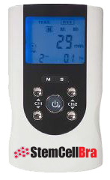
StemCellBra™ portable device design

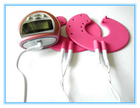
StemCellBra™ conductive electrode gel pad design and battery pack


StemCellBra™ connected by wire to stimulator and battery pack. The stimulator is to be worn on the belt line, hidden under clothes(comparable to people that are wired for microphones for TV)

STEMCELLBRA™ TECHNOLOGY
What sets StemCellBra™ apart from other breast augmentation therapies on the market as a bioelectric stimulating product is the fact that this product has the potential to NON-INVASIVELY increase breast size by attracting stem cells from the woman’s own bone marrow, fat, and circulating blood to breast tissue via SDF-1 (stromal derived factor 1), a protein notorious for being a homing signal to stem cells. Furthermore, StemCellBra™ potentially improves the blood flow in breast tissue itself through the increase of VEGF (vascular endothelial growth factor) protein expression.

SDF-1

StemCellBra™’s electrical stimulation mechanism induces the increased expression of SDF-1, known to be one of the most potent stem cell homing signals as well as to improve blood flow and tissue reconstruction in numerous studies in various models and tissues over the past decade without serious side effects reported.

The concept of the homing in the stem cell recruitment process is the most crucial step of stem cell transplantation¹. It is the navigation process that enables stem cells from red bone marrow through the blood, the vessels, and to organs throughout the body, and in this case, breast tissue.
The Expert Opinion on Biological Therapy journal published an article on SDF-1’s capabilities in regenerative medicine. The study shows that SDF-1 plays a huge role in tissue engineering. They found that when tissue is injured, the organ in the injured area overly expresses SDF-1, therefore an elevated SDF-1 level results². CD34+ progenitor cells, the cells found in red bone marrow that help create blood, are recruited and retained by SDF-1 to that injured site².

VEGF
Vascular endothelial growth factor (VEGF) regulates the development of new blood vessels from existing blood vessels by inducing growth, movement, and permeability of blood vessel cells, hence the capability of the StemCellBra’s bioelectric stimulation mechanism to potentially cause increased blood flow to the breast tissue when therapy is administered³. Cell Transplantation journal presented a study that indicates in situ electrostimulation, through a cell and cytokine free stimulation system, enhanced heart muscle function and increased blood vessel development through the production of VEGF⁴. In situ electrostimulation is the face of the future in the repair of the heart and other organs; it also has the capability of preparing tissue for cell-based therapy treatment⁴.

INITIAL PRE-CLINICAL ANIMAL STUDY RESULTS
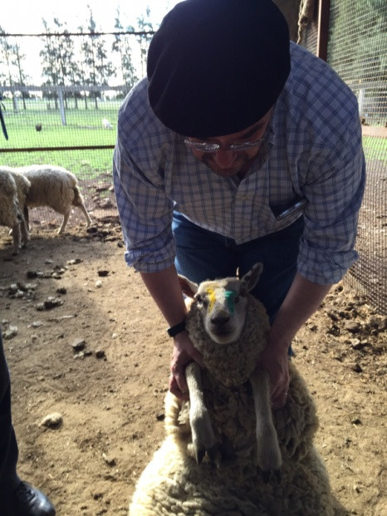

This was an ovine breast electrical stimulation pilot trial conducted in Buenos Aires, Argentina, supervised by Dr. Jorge Genovese, one of the founding members of Leonhardt’s innovation accelerator. The following factors were assessed in the trial: how the electrical stimulation effected potential growth of breast tissue, ovine breast tissue tolerance of the electrical stimulation, and monitoring mammary tissue histological changes, with a focus on new blood vessel development and stem cell populations⁵.
Three Romney marsh female sheep were involved in the study. The sheep had never given birth, were in reproductive age, and presented with an average weight of around 85 pounds⁵.

Three veterinarians were involved in the workflow of the study. One of the veterinarians assessed how the sheep’s external mammary glands tolerated the treatment. Another veterinarian was responsible for initial and final echo evaluation. A third veterinarian took the biopsy specimens’ collection. Out of these three veterinarians, the latter two veterinarians had no knowledge of the sheeps’ roles in the trial. In addition, the pathologist was also unaware of the sheeps’ roles in the trial⁵.

Every other day for 30 days, the StemCellBra™ self-adhesive electrodes were placed on the sheep mammary glands for 60 minutes in the following stimuli intervals: 250 uA, 100 Hz, and bipolar. At Day 0 and Day 30, an ultrasound exam was administered to the dorso-ventral aspect, latero-medial aspect and the volume of the mammary glands⁵.

The descriptions below reflect how each sheep was treated:

- SHEEP I: Control
  - The electrodes were attached BUT not connected.

- SHEEP II: Both breasts were treated

- SHEEP III: ONLY the right breast was treated

Hematoxilin-eosin was the media used to fix and evaluate the biopsy samples. The antibodies below were used:
- GOAT Anti-mouse IgG H8L (FITC) pre-absorber AB7064
- Anti CD105 Antibody (8A1) AB156756
- AntiCD34 Antibody (EP373Y) AB81289

During the study, the sheep showed no signs of pain or discomfort. Any other local or systemic adverse reactions were detected. The sheeps’ photoperiod in the season the study was conducted may have been a major influence in some of the treated sheeps’ mammary gland tissue increase.

This photoperiod is critical in ovine and determines changes in their sexual organs. The treated side experienced a minor increase in size, while the non-stimulated breast showed reduction in breast size typical for this time of year in sheep and seemed to be in a clear regressive mammary period based off the changed in the untreated side⁵.

Connective tissue proliferation without retracted areas was noted in the histology findings. Laxity abundance was also noted based on a reduced stromal cell population. Ductus and vessel increase at the parenchyma was present as well without signs of inflammation or scarring. CD34+ cells that in the control were around the in the control tissue, some vessels had CD34+ cells. In the treated tissue, these same cells were also detected in limited numbers. These findings were based on limitations due to restrictive access to specific reactives. In the treated glands, CD105+ were detected in the parenchyma.

_{SHEEP I: CONTROL} | _{Right}
_{SHEEP I: CONTROL} | _{Day 0} | _{Day 30} | _{Variation (%)}
_{Dorsoventral (mm)} | _{16,1} | _{17,7} | _{9,94}
_{Lateromedial (mm)} | ₄₁ | _{42,3} | _{3,17}
_{Area (mm2)} | ₆₅₅ | ₆₉₇ | _{6,42}
 | _{Left}
 | _{Day 0} | _{Day 30} | _{Variation (%)}
_{Dorsoventral (mm)} | _{16,16} | _{17,7} | _{9,53}
_{Lateromedial (mm)} | ₃₅ | ₃₀ | _{-14,3}
_{Area (mm2)} | ₄₇₈ | ₄₅₁ | _{-6,35}

_{SHEEP II: BOTH BREASTS TREATED} | _{Right}
_{SHEEP II: BOTH BREASTS TREATED} | _{Day 0} | _{Day 30} | _{Variation (%)}
_{Dorsoventral (mm)} | _{36,9} | _{43,3} | _{17,34}
_{Lateromedial (mm)} | _{47,5} | _{47,5} | ₀
_{Area (mm2)} | ₇₁₅ | ₈₆₉ | _{21,54}
 | _{Left}
 | _{Day 0} | _{Day 30} | _{Variation (%)}
_{Dorsoventral (mm)} | _{20,2} | _{28,1} | _{39.1}
_{Lateromedial (mm)} | _{39,5} | _{45,3} | _{14,68}
_{Area (mm2)} | ₅₆₀ | ₇₃₀ | _{30,4}

SHEEP III: RIGHT BREAST TREATED, LEFT BREAST NOT TREATED | _{Right}
SHEEP III: RIGHT BREAST TREATED, LEFT BREAST NOT TREATED | _{Day 0} | _{Day 30} |  | _{Variation (%)}
_{Dorsoventral (mm)} | _{36,9} | _{37,9} |  | _{2,71}
_{Lateromedial (mm)} | _{34,6} | _{44,8} |  | _{29,47}
_{Area (mm2)} | ₇₂₀ | ₇₆₄ |  | _{5,5}
 | _{Left}
 | _{Day 0} |  | _{Day 30} |  | _{Variation (%)}
_{Dorsoventral (mm)} | _{24,7} |  | _{27,1} |  | _{9,72}
_{Lateromedial (mm)} | _{44,2} |  | _{37,9} |  | _{-5%}
_{Area (mm2)} | ₇₁₅ |  | ₅₅₉ |  | _{-21,81%}

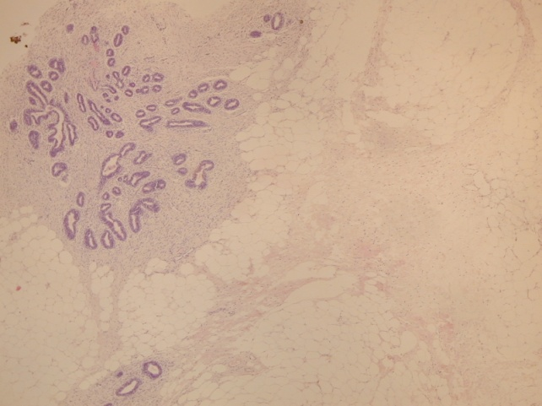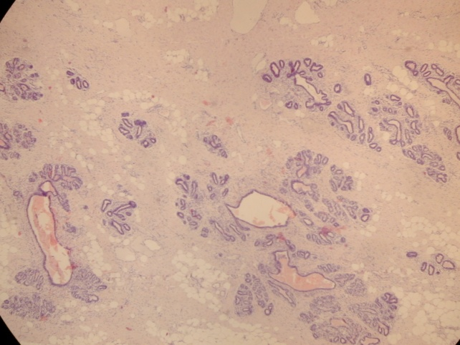
A
B
Hematoxylin - eosin. 4X
A. Control. B. ES
Treated gland show less fat, and connective tissue augmentation. In B the increase of collagen is not associated to evidence of tissue retraction. An increase of vessels around breast alveoli is also observed⁵.
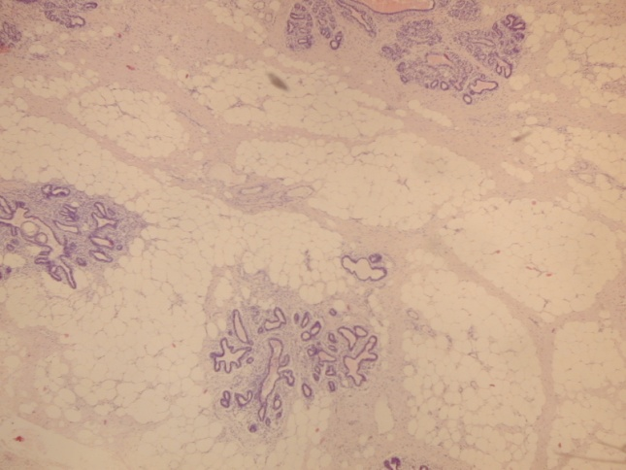
C
C.
H-E. Control in animal treated just in one gland.
Even though this gland was not electrically stimulated, the pathologist reported a little to moderate increase in connective tissue⁵.

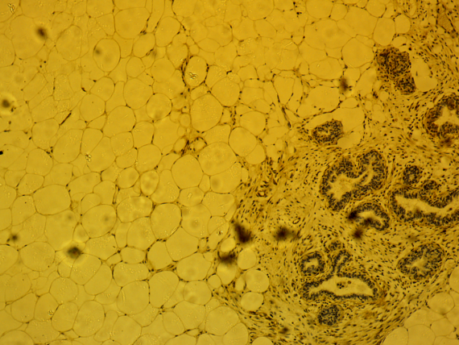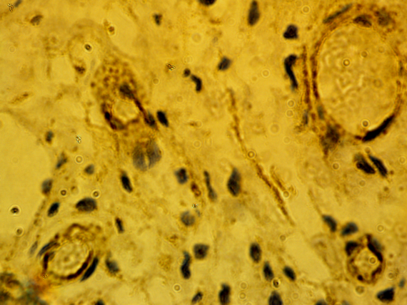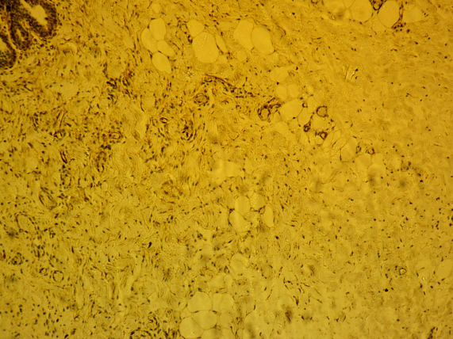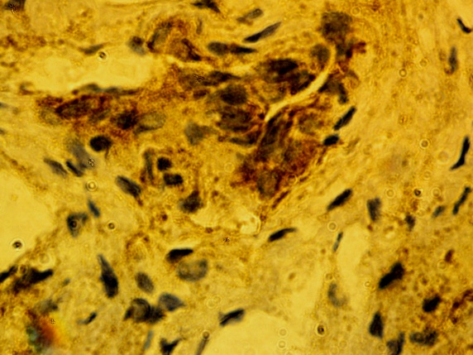
D
E
F
G
CD34 cells. D and E, control. F and G, ES. (Important background due to developing system used). In the treated sheep, groups of positive cells in the tissue are present at high magnification. The sheep control subject presented with positive cells that correlated to vessels.

CD105 cells. The media background was intense based on the developing system used. According to the pathologist, CD105 positive cells were present in the treated sheep samples. At least, with the above-mentioned limitation no CD105 cells were found in the control samples⁵.

In summary, The StemCellBra™ is a revolutionary and exciting product that could change the face of the breast augmentation industry based on these unique qualities that sets it apart from other therapies on the market:
- First ever bra of its kind that is currently undergoing early stage development testing in collaboration with research clinicians at Cedars Sinai UCLA
- StemCellBra™ can potentially enlarge breast size without the risk of invasive surgery
- The StemCellBra™ concept came from a patented Leonhardt electrical stimulator that attracts stem cells to heart tissue
- Unique bra design lined with a conductive gelatin that attracts stem cells that come from the woman’s own bone marrow and fat, to breast tissue
- The first U.S. studies will likely be combined with fat grafting in ladies whom are recovering tissue lost from breast cancer
- Has the potential to enlarge the breast by one cup size (20-30% volume increase) in as little as 4-8 weeks of electric stimulator therapy, administered 60 minutes every other day
- Instigates the over expression of the stromal derived factor 1 protein (SDF-1), a protein notorious for being a homing signal to stem cells
- Attracts stem cells through SDF-1 from bone marrow, fat, and circulating blood to augment breast tissue non-invasively
- Improves breast tissue blood flow through increased VEGF protein expression
- The future Stem Cell Bra stimulator itself will be light weight and the size of a nickel with one attached to each cup of the bra on the side
- The study of this device is moving forward with appropriate care and high caution understanding potential risk factors and side effects

REFERENCES
- Lapidot, T., Dar, A., & Kollet, O. (2005). How do stem cells find their way home? Blood, 106(6), 1901-1910. Accessed November 14, 2018. https://doi.org/10.1182/blood-2005-04-1417.

- Ting Ting Lau & Dong-An Wang (2011) Stromal cell-derived factor-1 (SDF-1): homing factor for engineered regenerative medicine, Expert Opinion on Biological Therapy, 11:2, 189-197, DOI: 10.1517/14712598.2011.546338

- E. Yaniz-Galende, R.J. Hajjar,16 - Stem cell and gene therapy for cardiac regeneration, Editor(s): Ren-Ke Li, Richard D. Weisel, Cardiac Regeneration and Repair, Woodhead Publishing, 2014, Pages 347-379,
ISBN 9780857096586, https://doi.org/10.1533/9780857096708.4.347.

- Spadaccio, C., Rainer, A., Marco, F. D., Lusini, M., Gallo, P., Sedati, P., … Genovese, J. A. (2013). In Situ Electrostimulation Drives a Regenerative Shift in the Zone of Infarcted Myocardium. Cell Transplantation, 22(3), 493–503. https://doi.org/10.3727/096368912X652977

- Genovese J. et al. (2018). Ovine Breast Electrical Stimulation. Unpublished raw data.

