September 7, 2020
Use of Bioelectric Stimulation for the Treatment of Hypertension:
A Pilot Study

Introduction: In the United States approximately 80 million Americans have hypertension (1). In Brazil, hypertension affects 32.5% (36 million) of the adults, including over 60% of the elderly, contributing direct or indirectly to 50% of the deaths due to cardiovascular disease (CVD) or Stroke. In 2013 there were 1,138,670 deaths, 339,672 of which (29.8%) due to CVD, the major cause of death in Brazil (2). Along with DM, its complications (cardiac, renal and stroke) have high impact on loss of work productivity and on family income, estimated as US$ 4.18 billion from 2006 to 2015.
Currently, non-pharmacological therapeutic methods are being used to treat resistant hypertension (RH). These are invasive, require long term follow up to monitor the results and may cause unwanted complications during and after the procedure, besides being expensive(3). These interventions and devices have yet to show the ability to reduce the dose or number of medications needed to control hypertension.

Transcutaneous electrical nerve stimulation (TENS) has been a useful modality for pain control (4) since the gate control theory was introduced by Melzack & Wall (5). BES has also shown to be effective in the reduction of sympathetic activity in healthy subjects and individuals with cardiovascular diseases. This form of neuromodulation is being used to treat a wide variety of medical conditions. In healthy subjects, sympathetic activity decreases (6) after low-frequency BES. In addition, patients with hypertension show a reduction of Blood Pressure (BP) after low frequency BES (7),(8) and, in heart failure patients, BES decreases sympathetic activity (9) largely as evidenced by reduction in heart rate.
Study Goal:
The goal of this study is to compare the use of TENS therapy to improve blood pressure control when applied to the paravertebral area between C7-T4 alone, or this location plus additional stimulation sites including wrist, ankle, and ear lobe.

Study design: Prospective, randomized, 2 arm, open label, controlled trial
Target Subjects: Patients with a diagnosis of essential hypertension.
Number of Patients to be Enrolled: 30
Number of study sites: 2-4
Duration of Study: 4 weeks
Number of Treatments: 10
Frequency of Treatments: 3 x’s/week for 2 weeks, then 2x’s/week for 2weeks
Duration of Each Treatment: 30 minutes

Inclusion criteria:
Age: 20-75 years
Sex: male or female
Documented hypertension: systolic blood pressure (SBP) > 150 mm Hg and/or Diastolic Blood Pressure (DBP) > 90 mm Hg on at least two measurements in a physician office.

Exclusion criteria:
Myocardial infarction past 3 months
History of stroke in past with residual neurologic deficit
Active smoking
Change in drug therapy in the 2 months preceding the study.
Serum Creatinine > 3.0 ng/ml or GFR < 30 ml/min

Baseline BP recording:

Each subject will have a 24 hr ambulatory blood pressure monitor placed with automatic cuff inflation every 15 minutes from 8 AM-10 PM, and every two hours from 10 PM-8 AM to establish the baseline BP control with mean, peak, and lowest BP recorded.

Treatment Arms:

Eligible subjects will be randomly assigned by electronic randomization (www.randomization.com), to the one of three groups of 10 patients each:

Group 1: Cervical Paravertebral Stimulation:

- TENS will be applied bilaterally in the cervicothoracic ganglion region located between the C7 and T4 vertebral processes for 40 min three times weekly for a total of 4 weeks. (Figure 1)

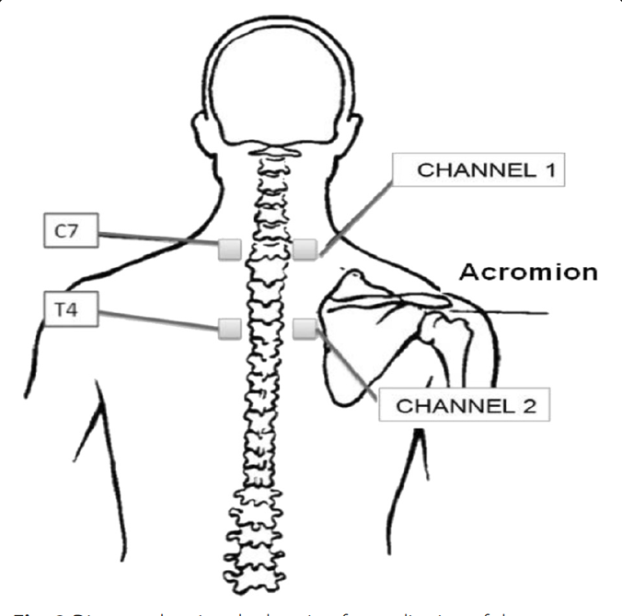

CERVICAL PARAVERTEBRAL

Group 2: Cervical Paravertebral, Plus Ear, Wrist, and Ankle Stimulation
- TENS will be applied in the cervicothoracic ganglion region located between the C7 and T4 vertebral processes, plus wrist and ankle via electrodes provided by the sponsor for 30 min three times weekly for a total of 4 weeks.

Group 3: Stimulation of the kidney alone with electrodes anterior and posterior to both kidneys to target increase in circulating levels of the protein Klotho

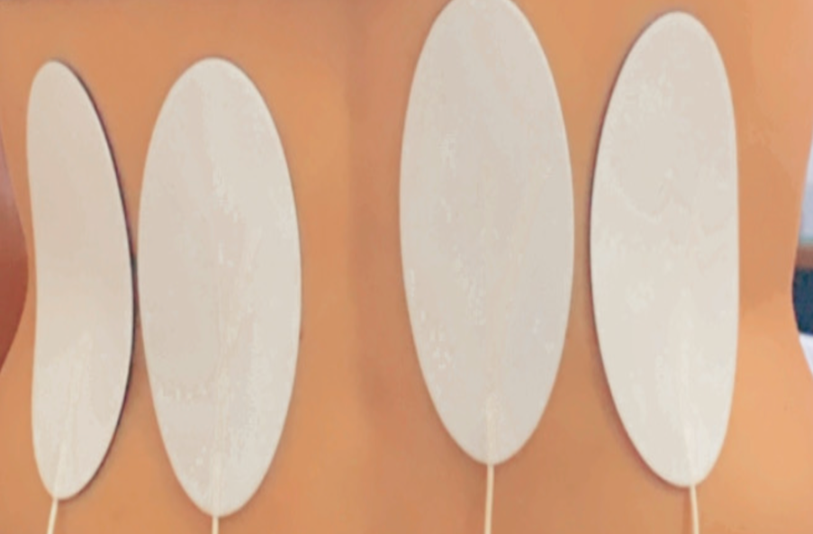
PAIRED ELECTRODES ON THE BACK OVER KIDNEYS

Application of treatment electrodes:

- Adhesive electrodes measuring 9x5 cm will be placed on the bilateral paravertebral region of the spine region from C7-T4
- Before the application of TENS (METTLER DEVICE), the skin site for the current application will be cleaned with alcohol to avoid any barrier conduction of the electrical current.

Stimulator to be used: FDA and CE Mark approved Mettler 240 desktop stimulator.

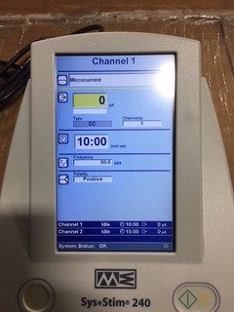

PROTOCOL:
Patients will rest for 15 minutes and, during the first treatment period will fill out the evaluation form, which contains identification data and questions about the patient’s clinical status, such as weight and height. Before and after the intervention, blood pressure and heart rate over one minute will be measured. The micro-current from the stimulator will be delivered at patients selected sensory-level intensity, adjusted every 5 minutes by the sensory threshold as tolerated by each subject, but with no motor contraction or pain reported. The sessions will take place at the same time of the day throughout the protocol. The participants will be comfortably accommodated in an acclimatized room (23.C) in supine position, with head elevation of 30° and knees resting on a wedge. All participants will be asked to not perform exhaustive exercises and ingest caffeine at least twelve hours before the intervention, and they were instructed to have a meal before the assessment.

END POINTS:
Arterial Blood Pressure
Blood Pressure (BP) will measured by 24 hour recording before and at the end of the study, as well as at each treatment session as proposed by the VI Brazilian Guidelines on Hypertension (2), with an automatic calibrated device, model HEM-705CP (Omron Healthcare Inc., Illinois, USA), and the cuff adjusted for arm circumference. The subject will be seated and three measurements will be obtained. Then the respective mean value will be calculated, which was used in the data analysis.

Statistical Analyses

The normality of the variables was verified by the Shapiro-Wilk test. Changes were made to variables that did not meet this assumption, such as natural logarithm, square root and reverse. For normally distributed variables, analyses of variance (ANOVA) were performed at baseline and post intervention, and Kruskal-Wallis tests will be used for variables that did not meet the assumption. The comparison between moments will be carried out using Student’s t test or Wilcoxon as the distribution of variables. A P- value of <0.05 will be considered statistically significant for all tests. All analyses will be performed with the SPSS 22.0 software (SPSS, Chicago, IL, USA).

Primary outcome measure: BLOOD PRESSURE
The primary outcome measure will be the change from baseline in the mean peripheral blood pressure by 24 hour monitor of individuals with resistant hypertension after transcutaneous electrical nervous stimulation using the three different electrode placements of paravertebral and the combination of ankle and wrist, and kidney placement of electrodes.
Secondary outcome measures:
Heart Rate Variability
The mean heart rate at rest and variability over 24 hours will be calculated and compared between the three treatment arms.

Adverse events: The adverse events will be investigated by open questions at the time of each treatment session, which will address general symptoms and the presumed adverse effects of the electrostimulation used in the trial. Laboratory adverse events, such as metabolic changes and inflammatory markers, will be investigated at the final
visit of the participants.
Missing or dropout: Participants will be registered with a phone number and address for further contact in case of missing outlined visits. The investigator is allowed to enroll additional subjects for any subject that fails to complete the entire course of 10 treatments and drops out early. Additional patients beyond the planned total of 30 subjects, with 10
Subjects/group, can be added at the agreement of the sponsor and investigator.

References

1. Mozaffarian D, Benjamin EJ, Go AS, Arnett DK, Blaha MJ, Cushman M, et al. Heart disease and stroke statistics-2016 update a report from the American Heart Association. Vol. 133, Circulation. 2016. 38–48 p.
2. Malachias MVB, Souza WKSB, Plavnik FL, Rodrigues CIS, Brandão AA, Neves MFT, Bortolotto LA, Franco RJS, Poli-de-Figueiredo CE, Jardim PCBV, Amodeo C, Barbosa ECD, Koch V, Gomes MAM, Paula RB, Póvoa RMS, Colombo FC, Ferreira Filho S, Miranda RD, Machado CA MJH. 7 th Brazilian Guideline of arterial hypertension. Arq Bras Cardiol. 2016;107(3):1–104.
3. Vilela-Martin JF, Giollo-Junior LT, Chiappa GR, Cipriano-Junior G, Cardoso Vieira PJ, Ricardi F dos S, et al. Effects of transcutaneous electrical nerve stimulation (TENS) on arterial stiffness and blood pressure in resistant hypertensive individuals: Study protocol for a randomized controlled trial. Trials [Internet]. 2016;17(1):1–13. Available from: http://dx.doi.org/10.1186/s13063-016-1302-8
4. DeSantana JM, Walsh DM, Vance C, Rakel BA, Sluka KA. Effectiveness of transcutaneous electrical nerve stimulation for treatment of hyperalgesia and pain. Curr Rheumatol Rep [Internet]. 2008 Dec;10(6):492–9. Available from: http://www.ncbi.nlm.nih.gov/pubmed/19007541
5. Melzack R, Wall PD. Pain Mechanisms: A New Theory. Science (80- ) [Internet]. 1965 Nov 19;150(3699):971–8. Available from: https://www.sciencemag.org/lookup/doi/10.1126/science.150.3699.971
6. Stein C, Dal Lago P, Ferreira JB, Casali KR, Plentz RDM. Transcutaneous electrical nerve stimulation at different frequencies on heart rate variability in healthy subjects. Auton Neurosci [Internet]. 2011 Dec;165(2):205–8. Available from: https://linkinghub.elsevier.com/retrieve/pii/S1566070211003651
7. Kaada B, Flatheim E, Woie L. Low-frequency transcutaneous nerve stimulation in mild/moderate hypertension. Clin Physiol [Internet]. 1991 Mar;11(2):161–8. Available from: http://doi.wiley.com/10.1111/j.1475-097X.1991.tb00109.x
8. Campbell TS, Ditto B. Exaggeration of blood pressure-related hypoalgesia and reduction of blood pressure with low frequency transcutaneous electrical nerve stimulation. Psychophysiology [Internet]. 2002 Jul;39(4):473–81. Available from: http://www.ncbi.nlm.nih.gov/pubmed/12212639
9. Labrunée M, Despas F, Marque P, Guiraud T, Galinier M, Senard JM, et al. Acute electromyostimulation Decreases Muscle Sympathetic Nerve Activity in Patients with Advanced Chronic Heart Failure (EMSICA Study). Baumert M, editor. PLoS One [Internet]. 2013 Nov 12;8(11):e79438. Available from: https://dx.plos.org/10.1371/journal.pone.0079438
10. Montano N, Ruscone TG, Porta A, Lombardi F, Pagani M, Malliani A. Power spectrum analysis of heart rate variability to assess the changes in sympathovagal balance during graded orthostatic tilt. Circulation [Internet]. 1994 Oct;90(4):1826–31. Available from: https://www.ahajournals.org/doi/10.1161/01.CIR.90.4.1826
11. Ferreira JB, Plentz RDM, Stein C, Casali KR, Arena R, Lago PD. Inspiratory muscle training reduces blood pressure and sympathetic activity in hypertensive patients: A randomized controlled trial. Int J Cardiol [Internet]. 2013 Jun;166(1):61–7. Available from: https://linkinghub.elsevier.com/retrieve/pii/S0167527311017980
12. Ngai SPC, Jones AYM. Changes in Skin Impedance and Heart Rate Variability with Application of Acu-TENS to BL 13 ( Feishu ). J Altern Complement Med [Internet]. 2013 Jun;19(6):558–63. Available from: http://www.liebertpub.com/doi/10.1089/acm.2012.0097
13. Vieira PJC, Ribeiro JP, Cipriano G, Umpierre D, Cahalin LP, Moraes RS, et al. Effect of transcutaneous electrical nerve stimulation on muscle metaboreflex in healthy young and older subjects. Eur J Appl Physiol [Internet]. 2012 Apr 28;112(4):1327–34. Available from: http://link.springer.com/10.1007/s00421-011-2084-z
14. Oparil S, Acelajado MC, Bakris GL, Whleton PK, et al. Hypertension. Nat Rev Dis Primers. 2018;4:18014. doi;10.1038/nrdp
15. Carey RM, Clahoun DA, Bakris GL, Brook RD, White WB, et al. Resistant Hypertension: A Scientific Statement of the Am Heart Assoc. 2018. Circulation;72(5):5.3-90
16. Muntner, P, Shimbo , Carey RM, Charleston, JB, et al. Measurement of Blood Pressure in Humans: A Scientific Statement from the Am Heart Assoc. Circulation;73(5):35-66.
17. Forouzanafar MH, Oparil S, et al. Global, Regional, and National Comparative risk assessment of 79 behavioral, environmental, occupational, and metabolic risks: A systemic analysis for the Global Burden of Disease Study. Lancet. 2014;388:591-598.
18. Mills KT et al. Global disparities of Hypertension Prevalence and Control: A systemic analysis of population based studies in 90 countries. Circulation. 2016;134:441-450.
19. Takenaka T, Kobori H, Hayashi M, et al. Klotho protein supplementation reduces blood pressure and renal hypertrophy in a diabetic mouse model of Type 2 Diabetes. 2019. Acta Physiol. 225(2). E 13930. Doi10.111.alpha.13190.

