Use of Bioelectric Stimulation for the Treatment of Hypertension: A Pilot Study

Principal Investigator: Rodrigo Della Méa Plentz, PhD
Telephone: +55 (51) 991131651
Email: roplentz@yahoo.com.br
Department of Physical Therapy
Universidade Federal de Ciências da Saúde de Porto Alegre
Rua Sarmento Leite, 245, Porto Alegre, Rio Grande do Sul, Brazil - CEP 90050-170
Co-Principal Investigator: Jociane Schardong, PhD
Telephone: +55 (5) 981348114
Email: joci_fisioufsm@yahoo.com.br
Irmandade Santa Casa de Misericórdia de Porto Alegre Hospital
Rua Professor Annes Dias, 295 - Porto Alegre, Rio Grande do Sul, Brazil – CEP 90020-090
Location of Study: São Franscisco Hospital of Irmandade Santa Casa de Misericórdia de Porto Alegre
Sponsor: PressureStim, a subsidiary of Leonhardt Ventures

Study Goal: The goal of this study is to compare the use of transcutaneous electrical nerve stimulation (TENS) therapy to improve blood pressure control when applied at different anatomical sites.
Study design: Prospective, randomized, 3 arm, open label, controlled trial.
Target Subjects: Patients with a diagnosis of essential hypertension.
Number of Patients to be Enrolled: 60
Number of study sites: 2-4
Duration of Study: 4 weeks
Number of Treatments: 10 sessions
Frequency of Treatments: 3 x’s/week for 2 weeks, then 2x’s/week for 2weeks
Duration of Each Treatment: 30 minutes
Simulator to be used: FDA 510K approved Mettler model 240

Inclusion criteria:
- Age: 20-75 years
- Sex: male or female
- Documented systemic arterial hypertension: systolic blood pressure (SBP) ≥ 140 mm Hg and/or Diastolic Blood Pressure (DBP) ≥ 90 mm Hg on at least two measurements in a physician office.

Exclusion criteria:
- Patients with diabetes
- Patients with congestive heart failure
- Patients with cardiac pacemaker
- Patients with serum creatinine > 2.5 ng/ml or GFR < 30 ml/min
- Obesity
- Change in drug therapy in the 2 months preceding the study
- Active smoking

Treatment Arms: Eligible subjects will be randomly assigned by electronic randomization with allocation ratio of 1:1:1 to the one of three groups:

Group 1 - Cervical paravertebral stimulation

TENS will be applied bilaterally in the cervicothoracic ganglion region located between the C7 and T4 vertebral processes (figure 1).

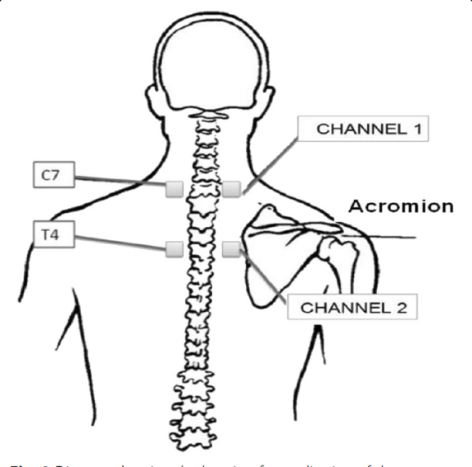
Figure 1. Electrode arrangement for cervical paravertebral stimulation
Group 2 - Cervical paravertebral plus ear, wrist and ankle stimulation

TENS will be applied in the cervicothoracic ganglion region located between the C7 and T4 vertebral processes, plus ear, wrist and ankle via electrodes provided by the sponsor.

Group 3 - Stimulation of the kidneys

TENS will be applied on abdomen and dorsal region at the level of the 10th thoracic vertebra as the figure 2 to target increase in circulating levels of the Klotho protein.
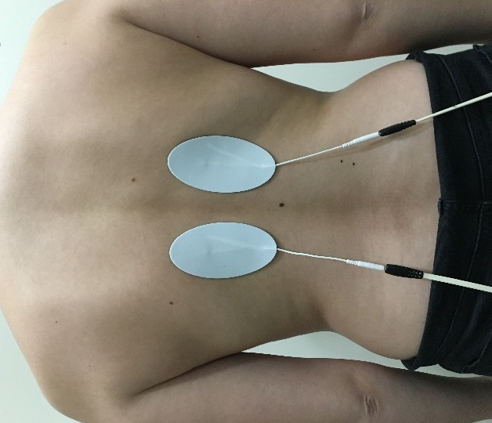
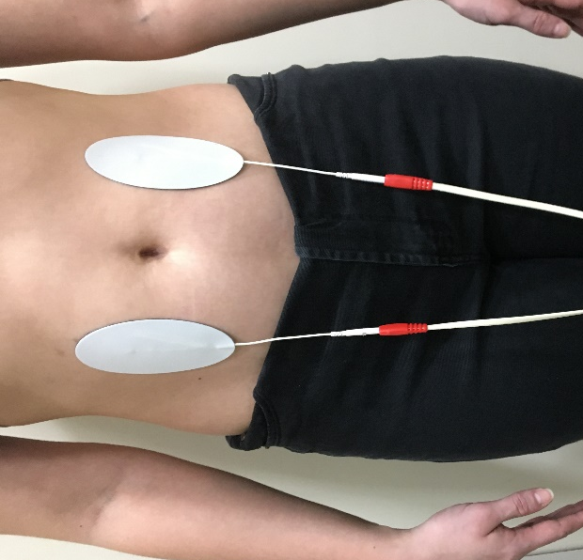

Figure 2. Electrode arrangement for stimulation of the kidneys

Protocol:
Patients will rest for 30 minutes before any procedure. Blood pressure and heart rate will be measured before and after the intervention. To blood pressure the subject will be seated and three measurements will be obtained. The heart rate will be measured with a pulse oximeter. The electrical stimulation will be delivered at patients selected sensory-level intensity, adjusted every 5 minutes by the sensory threshold as tolerated by each subject, but with no motor contraction or pain reported. The sessions will take place at the same time of the day throughout the protocol. The participants will be comfortably accommodated in an acclimatized room (23ºC) in supine position, with head elevation of 30° and knees resting on a wedge. All participants will be asked to not perform exhaustive exercises and ingest caffeine at least twelve hours before the intervention. Before the application of TENS, the skin site for the current application will be clean with alcohol to avoid any barrier conduction of the electrical current. TENS will be applied with a low frequency (4 Hz) and pulse width of 200 µs.

Outcomes and Evaluations

Primary Outcome: Arterial blood pressure

Blood pressure (BP) will measured by 24 hours by ambulatory blood pressure monitoring (ABPM) recording at baseline and at the end of the study (after 10 applications of TENS). Each subject will have a 24 hours ambulatory blood pressure monitor placed with automatic cuff inflation every 15 minutes from 8 AM-10 PM, and every two hours from 10 PM-8 AM to establish the baseline BP control with mean, peak, and lowest BP recorded.

Secondary Outcomes: Autonomic control
The analysis of autonomic control will be performed with a Polar® frequency meter (model RS800CX, Finland). The sensor belt will be placed on the patient's chest and the signal will be automatically stored in the RR interval and analyzed later by the Kubios 2.0 software.
The patients will remain in supine position and stretcher head at 45 ° of inclination. They will be instructed to remain calm and without movement. After a brief rest period to stabilize the cardiac frequency (20 minutes), the signal will be recorded for 10 minutes in this position. To assess the sympathetic nervous system response, the signal will be recorded for another 10 minutes in the orthostatic position (tilt).

Statistical Analyses
The comparison between pre and post moments will be carried out using Student’s t test or Wilcoxon as the distribution of variables. To assess the effect of therapy analysis of variance (ANOVA) will be performed for normally distributed variables ou Kruskal-Wallis test for variables that did not meet the assumption. A p-value of <0.05 will be considered statistically significant for all tests. All analyses will be performed with the SPSS 22.0 software.

