TestiStim Initial Subject – A Brief Overview

An overview of the experience and limited data gathered by the inventor (and initial Subject) of what would become the TestiStim prototype device. It should be noted that the Subject was dependent upon his own union health care coverage for testing; and that his doctor at the time was unwilling to authorize tests for anything other than standard Testosterone Replacement Therapy. This limited the amount of useful TestiStim data the Subject could gather other than his initial Testosterone levels prior to the TestiStim device and, more recently, his current Testosterone levels utilizing only the stimulus provided by the TestiStim device.

INITIAL IMPETUS – OCT-DEC 2010


Subject is 6’3” (190cm) and in 2010 was 52 years of age. His weight was approximately 240 pounds (109kg), which gave him a borderline obese Body Mass Index of 31. Subject was reluctant to be photographed during this period, but this photo from Nov 2010 was located. Concerned for his own health, Subject began a program of diet and exercise. Subject had dieted and exercised successfully at earlier points in his life but now found it unexpectedly difficult. He was lethargic, weak, and dieting progressed very slowly. Suspecting that he might be suffering from age-related Testosterone reduction, he consulted his doctor, who authorized a blood test for Testosterone. Results (below) showed that a Testosterone level of only 310; a mere ten points above a medically Low Testosterone level. (Normal: 300-720)

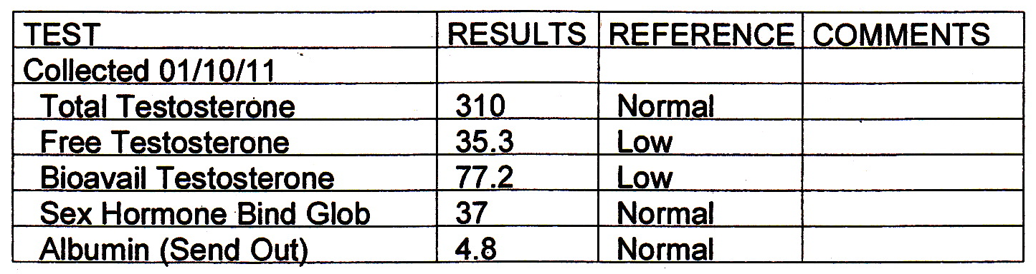

Despite this borderline low Testosterone level, Subject’s doctor was initially reluctant to prescribe TRT (Testosterone Replacement Therapy) since a level of 310 was still inside “normal” range. Subject, frustrated, began researching ways in which he might increase his own Testosterone production. Having read of studies in which brain activity was stimulated by application of low-voltage current (tDCS), Subject decided to attempt using low-voltage stimulation to boost his own Testosterone production.

IMPLEMENTATION AND DEVELOPMENT – 2011 to PRESENT

Since the testes normally produce Testosterone during sleep, Subject hypothesized that a device worn while sleeping would likely be the most effective method. He began assembling a number of prototypes, quickly deciding that tight-fitting briefs made the best full time contact in the necessary areas. Subject experimented with a number of different types of electrodes, positions, and voltages (some of which were quite painful) before finally settling on the system of carbon/gel electrodes and voltages described in the patent.

Utilizing the TestiStim prototype, Subject regained vigor and was able to successfully exercise and diet once more.

Shortly thereafter, the Subject’s doctor decided to authorize a prescription for AndroGel despite his initial reluctance. The Subject, curious to see what would happen, began using both the TestiStim prototype and AndroGel. Data gathered during this period is not useful, as there are too many variables. Subject eventually stopped using the AndroGel altogether and resumed using only the TestiStim device.

His previous doctor also retired, so the Subject, in being assigned a new doctor, explained that he was interested in “establishing a baseline” in his natural Testosterone level. (Subject did not mention that he was using the TestiStim prototype.)

Two tests a month apart were almost identical, showing that using the TestiStim prototype, Subject’s Testosterone level is now almost 500, an increase of nearly 190 points over his original 310; and well within normal range (300-720), especially for a now 61-year-old man.
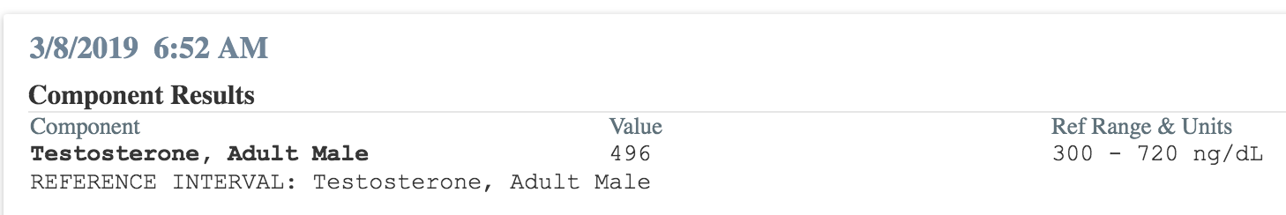

Subject has also lost approximately 60 pounds (27 kilograms) and currently weighs 185 pounds (84 kilograms) for a healthy BMI of 23. Blood pressure, EKG, and lab work show him to be in good physical shape.

It should be noted that Subject was using the basic TestiStim prototype. He is interested to see what further developments of the device may bring.

